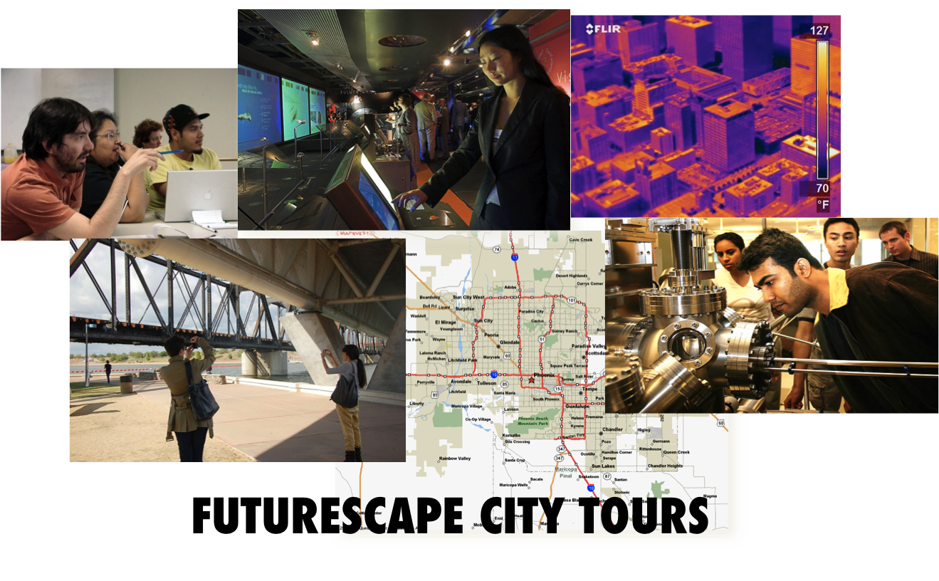

Materials to bring –
- recording device for interviews
- extra camera and cable; computer (for uploading later)
- tour bags
- cameras

Things to do—
- prep for transportation moderation;
- prep for solar moderation
- prep for water moderation
- deliver drinks and cookies to her office Friday
- pack tour bags
- all members should test out Flickr in advance.

Bags should include: donated water bottles (filled), workbook, pen, nametags, parking validation (?), metro ticket, sunflower seeds, granola bar, exhibition mini flyers
* Bags will be packed in Cynthia’s office Friday from 1-2pm

Aims of Session for Participants:
- Learn about the city through photography, conversations with stake holders, and walking

Aims for Researchers:

- Examine how photography, a walking tour, and the integration of science and technology experts plays a role in capacity building, confidence, and knowledge
Participants: who’s coming? Total will be about 15 (plus Rider and Gretchen )

X Blakely | P | regblakely@gmail.com | Instructional designer
X Calaway | P | iconaklast@yahoo.com | "Odysee of the mind" program director
X Yildirim | P | yildirimmuharrem@gmail.com | Media Arts & Sciences PhD student
X Cornejo | P | aaron.a.cornejo@gmail.com
Sylvia X | E | sylvia.planer@gmail.com | Electrical engineering
Dulce X | P | olin.yoli@asu.edu | PhD student
Robert X | S | RNmelikian@cox.net | author of "Vanishing Phoenix"
Shannon X | P | shannonselleck@gmail.com | Nurse
Scott X | P | scott.muir@asu.edu | Librarian
Perry X | P | perryf.allen@yahoo.com | 9th grade history teacher
Roger X | E | redsnapper@alumni.caltech.edu | engineer (Semiconductors)
Blakely X | P | Blakely.McConnell@asu.edu | Soundwalks
Art X | P | ArtFel@moose-mail.com
Jim X | S | jstack6@juno.com | wireless telecommunications
Wendoly X | S | wendoly@phxrevitalization.org | community capacity building
Paul X | S | paulhickey@gmail.com | hobbies: photography, 3D printing

Note the morning is tight, but we also want to set people off talking and taking pictures and focusing on the big questions of the tour: how might emerging technologies transform Phoenix? What of sustainability? What of equity? What is your relationship to technology and how do you connect it to the urban environment?

Day Two – Dec 1st 9am to 5pm
Time | Focus | Methodology | Notes
7:45 am | Depart Tempe | Car pool | Cynthia to pick up Kathryn, Carlo, Jathan and Gretchen
8:15 am | Arrive @ Science Center |  | Mindy and Kelly to arrive @ 8am to meet Science Center contact
8:30 am | Coffee and informal welcome |  | Who is bringing coffee?  Snack?
9:00 am | Welcome | Cynthia: Welcome back- refresh from last time;  Goals of today; what is in store- the agenda; taking pictures; Carlo’s mini-interviews; bathroom stops; Monday’s event and First Friday event; your active engagement and questioning of experts and sites; use your workbook- Kathryn to walk through workbook; Sunscreen interlude…
9:10-9:30am | Walk to Biosciences | With team distributed throughout crowd, point out features of the landscape-Heritage Square, ASU downtown, APS, TGEN, empty lot, etc. Create atmosphere of curiosity- spark conversation. Encourage picture taking and note taking | Mindy and Kelly lead; Kathryn and Carlo bring up rear, herding
9:30-10:25 am | Biosciences | Group will need to go in shifts (approx. 10 people) to rooftop  Speakers names and bios below…  Transition point to note the sunflower garden… | Carlo to introduce speakers and moderate Q & A.  Jathan and Cynthia to ensure safety on climb  Notes: Kathryn
10:30-11:30 am | Biofuels demo | Conz to lead; Cynthia to introduce him | Be sure tour participants can sit; point out restrooms (maybe…)

Time | Focus | Methodology | Notes
11:30-noon | Graffiti walk towards UCENT | Another walk through town- Roosevelt Row; stop-over for Carlo’s talk about graffiti and nano products—values- What kind of social atmospheres might nano be used to create in our city? What might be the unintended consequences?  Walk along new construction sites; how will the old and new fit together? What will Phoenix look like in 30 years?  Pass by nursing building- all point out First Friday event.  Mindy to lead stop-over at pavement site. | Kelly to head directly to UCENT to get drinks and meet caterer; and to greet the Transportation panel.
12-1:30 pm | Lunch Discussion:  Transportation Panel | Mindy introduce speakers and moderate session;  Session to begin by 12:30 or as ready  Each speaker will introduce their concerns and curiosities in 5 minutes time;  Ask group, including panel, to work in 3’s develop 3 key questions they have for the panel…(FCT team not participating)- give 5-7 minutes)  Cynthia to transition session by explaining the Metro observation: Pretend you are an anthropologist interested in technological change, observing a strange culture; what would you write in your field book. A silent exercise. | Encourage folks to throw away lunch materials; leave a clean room  People should fill up water bottles and use the nice bathrooms  Notes: Kelly  Do we want to have groups write down their 3 questions on a flip chart- Kelly could store in her office?  Jathan to leave lunch at 1:30pm to meet water speakers
1:45 pm | Travel to canal via Metro  Stop at ??? | We can consider walking up Central for a moment- waiting for light rail ALL can talk about Trolley museum, about library, Westward Ho and other new condos- the old and the new? Who decides? In which ways does technology matter?  Silent observation field notes… | Each FCT team member to be responsible for 3-4 peoples’ entrance and exit to the metro.
2:15/30 pm | Canal- | On walk from Metro to Canal, you can ask people what they noticed in their observation  Jathan to lead- referencing again citizen interests and introducing speakers… | Get in shade…
3:30 – 4 pm | Travel to Science Center via metro | Upon return we explain about the photos and our support; many thanks; remind of workbook- make notes and BRING MONDAY (we will collect and return at First Friday or otherwise if requested); Quick de-brief: ‘what stood out about this day?’ | Group de-brief- Cynthia to offer her mobile number for tech support

To Do Post Tour:
- Print Photos
- Print images and print comments from work books on Tuesday
- De-brief (open meeting): Saturday after tour, until whenever
- Jot down ½ page reflection on how it went: highs, lows, lessons learned

