

We will be working with your ideas and reflections on Monday evening. BRING THIS WORKBOOK WITH YOU.

ASU Mercado C146

Join us to present your ideas about the future of Phoenix during First Friday.

5-9pm [presentation at 5:30pm]

Nursing Health Institute Building - Room 115, 550 N. 3rd St, Phoenix, AZ 85004

Past, Present and Future of Phoenix

Closing Session—Dec. 3rd 5pm

**Futurescape City Tours**

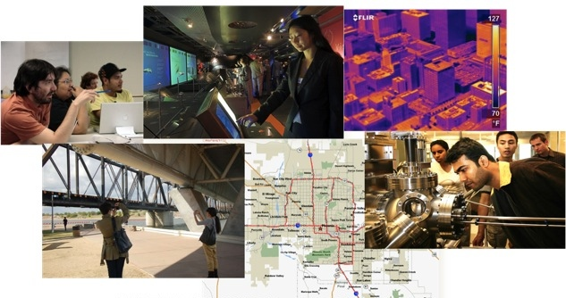

First Friday Gallery Event

_________________________________________________

#### Your Name:

2012

Fall

## Photo Log

|  |  |  |
| --- | --- | --- |
| Photo Title | Tag: past, present or future | Caption:  What struck you about this site?  What does this image evoke for you? |
|  |  |  |
|  |  |  |
|  |  |  |
|  |  |  |
|  |  |  |
|  |  |  |
|  |  |  |
|  |  |  |
|  |  |  |
|  |  |  |
|  |  |  |
|  |  |  |
|  |  |  |
|  |  |  |
|  |  |  |
|  |  |  |
|  |  |  |
|  |  |  |
|  |  |  |
|  |  |  |
|  |  |  |
|  |  |  |
|  |  |  |
|  |  |  |

Notes

2

### Looking differently at the city

The Futurescape City Tours aims to build the capacities among participants to appreciate the trade-offs, path dependencies and societal choices surrounding emerging technologies.

**Values shape how technologies are developed and adopted.**

How do our values shape the development, adoption, and use of nanotechnology*?*

**Technologies affect social relationships.**

How do everyday technologies affect our social relationships?

**Technologies are part of larger systems.**

How does one technology become connected into a larger system?

##### Uploading Your Photos

**Don't stop once you've taken your photos!** We'd like each image to be uploaded and accompanied by a caption describing the thinking behind it. **Photos and captions should be uploaded to Flickr and tagged with 'futurescape2012' and either 'past', 'present', or 'future'.**

On Monday the 3rd of December, you will work, as a group, with the photographs to create a gallery show that tells your story about technological change and the future of Phoenix.

Go through your photos and **pick 20 images** that capture your impressions of Phoenix. You will then upload the select photos to Flickr along with **2 tags and 1 caption**.

USING FLICKR: Uploading, tagging, and writing captions

If you have or wish to create a Flickr account, then you can use one of the following two options to contribute your photos:

* UPLOAD FROM YOUR PHONE

Download a Flickr app and upload

* UPLOAD FROM YOUR DESKTOP

Upload using a browser

TAG your photos with the tags ‘futurescape12’ and ‘past’, ‘present’ or ‘future’. Include your captions as DESCRIPTIONS:

1. Select the photo.
2. Click on ‘Add a Description’ and enter the caption.
3. Click on Tags and add the tag: ‘futurescape12’, click ENTER. Add second tag: ‘past’, ‘present’ OR ‘future’.
4. Repeat for each picture and click on **Upload Photos**.

If you do not have a Flickr account and do not want to set one up.

* UPLOAD BY EMAIL, Email each photo to [god95born@photos.flickr.com](mailto:god95born@photos.flickr.com). To add tags and a caption: Type ‘tags:’ in the subject line of the email followed by the list of tags you want added to the photo (e.g. futurescape12, past). The body of the email will serve as the caption of the photo.

After you have uploaded, tagged and described your photos, you can add your tagged photos to the Flickr group called “Futurescape 12”.

anthropolgies

We’ll

Moderator: Cynthia Selin

Writing lines

### technology in Society

22

3

## introduction

### Key questions

Where is the future emerging in Phoenix?

What is the role of technology in transforming the urban landscape?

Which futures do you want?

##### Water

2:30-3:30pm

The Grand Canal Trail

12-1:30pm

Arizona State University

10:30-11:30am

Aside of Heart Cafe

9:30-10:30am

Biosciences High School

##### Solar

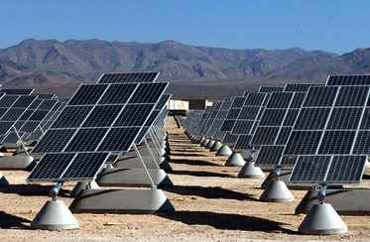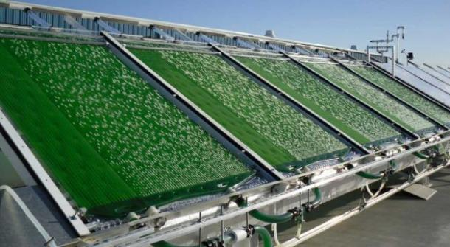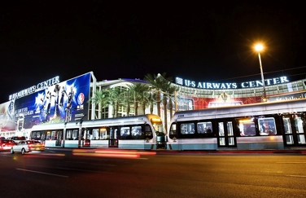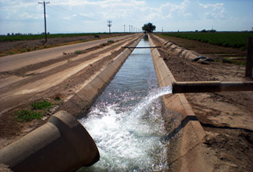

4

21

Now you’ve explored the city, considering how new technologies might shape the future. How do you see Phoenix in 30 years?

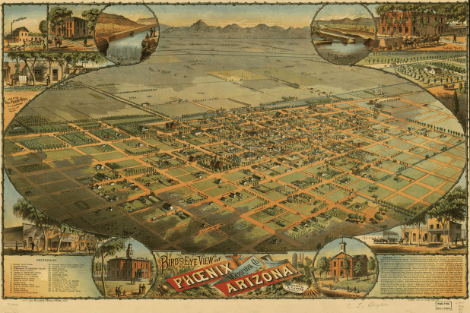

# Our Tour Route

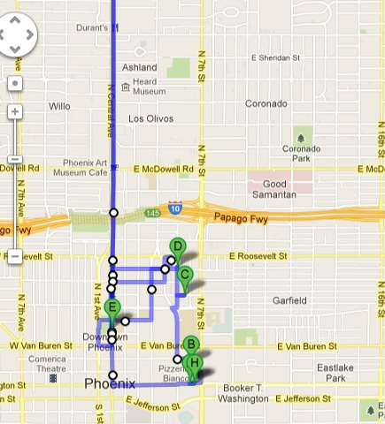

5

20

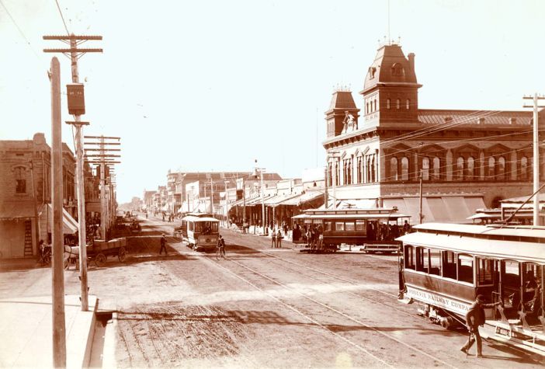

Washington and 1st (1911)

What’s here today? How has this street changed?

What will this area look like 100 years from now?

##### Photograph your Thoughts

The Futurescape City Tours project invites you to document your concerns and questions about the future of Phoenix. What memories and imaginations are in the landscape of a city, and how can we interpret them?

We’ll do this through a shared, attentive, walking tour of Phoenix. As you walk and visit sites, take photos and jot down your reflections.

At the end of the tour, choose 20 images that are most important to you and upload them to a shared website (instructions for how to do so are on page 22). Please create a caption for each picture that reveals your thoughts about the image. After you’ve uploaded the picture be sure to tag each one with “futurescape12” and then either “past”, “present”, or “future”. 🡪 🡪 🡪

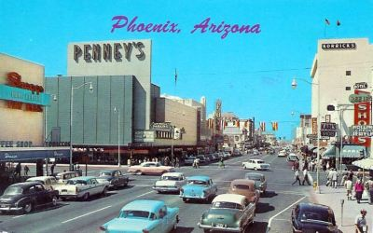

What brings you downtown today?

What brought people to town in the past?

What will bring people to town in the future?

6

19

##### Identify the FUTURE

##### What do you see?

##### Spot the signs of the PRESENT

##### Find futures in the PAST

As you wander, where do you see the future breaking through? What are the places that point to precursors of dramatic change?

As you explore, consider the history of Phoenix and the ways that the past defines the present. Which sites and images are of the past, but might continue to endure in the future?

Identify and photograph street signs, advertisements, shop fronts, vistas, and technologies – for instance – that capture the spirit of the present.

As you are taking pictures, write down what struck you about the image. Describe why you took the photo and what it means to you. Later you will develop captions for select photographs.

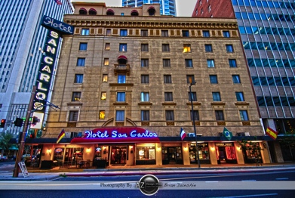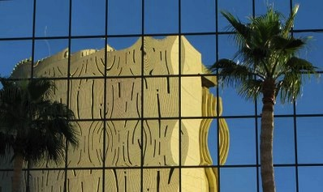

18

7

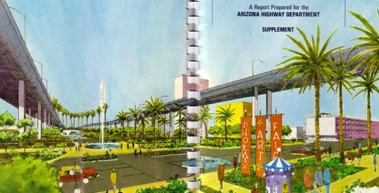

Today? Tomorrow? Yesterday?

What do you like about this depiction of I-10? Do you see any problems? Why did this plan never come to fruition? How would this design have changed our downtown?

##### Where is Nano?

##### Sunscreen

Particles at the nanoscale can be more chemically reactive and more easily absorbed in the body than their macro counterparts. In recent years, cosmetics and sunscreens have begun incorporating nanoscale particles. In sunscreen, smaller particles of zinc oxide make a shield that is transparent on the skin, instead of white and creamy.

There are concerns about the safety of these particles. Do the known risks of skin cancer outweigh the potential unknown risks of nanotechnology? Do you as a consumer have enough information to make these choices?



8

17

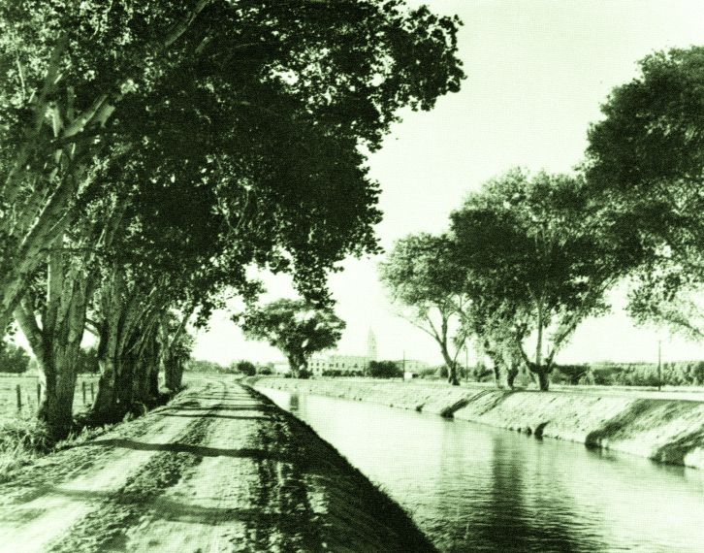

Canals have remained, but they are no longer lined with trees.

How has the lack of trees changed how we use the space around the canals?

##### Buildings

Nanotechnology offers design and fabrication at the molecular scale that can impact the construction of new buildings. Solar energy collecting paints, windows that change colors on demand, and concretes that do not absorb heat exist today. Nanoscale coatings can be used for surfaces of buildings to insulate, self-clean, offer UV protection, resist corrosion or waterproof.

There is uncertainty about the longer-term effects of these building materials. Are they recyclable? Do they leach dangerous particles? Who decides the safety of new coatings and paints? What level of risk is acceptable? Will these technologies be used in new building construction or also to preserve historic buildings?

##### Agenda

##### Biofuels

##### Transportation



##### Water

What are the key issues around the future of water in Arizona? Which technologies might make a difference?

**Kyle Doudrick**, Graduate Research Assistant, Environmental Engineering, ASU

**Daniel Higgins**, NSF Postdoctoral Research Fellow, Consortium for Science Policy and Outcome, ASU

## Tomasz Kalinowski, Graduate Research Associate, Environmental Security, The Biodesign Institute, ASU

Moderator: Jathan Sadowski



16

9

One of the ideas behind the Tours is to notice what we might ordinarily take for granted. What kind of habits do we develop around technology? How do the technologies of the city, like the light rail, shape the way we interact with our landscape and with each other?

During the ride, pretend you are anthropologist exploring a strange land. **What do you notice?** Use the space below to take your field notes:

## Observation on the LIght rail

##### Solar

What does the future hold for solar energy in Phoenix? What are the different options for integrating solar energy in the community?

**Deedee Falls**, Principal, Biosciences High School

**Alec Kindall,** Biosciences HS student

**Dennis Chang**, NRG Energy

**Christiana Honsberg**, Professor, School of Engineering, ASU & the Director of the Quantum Energy and Sustainable Solar Technologies Engineering Research Center

**Suzanne** **Fallender**, Director of CSR Strategy & Communications, Corporate Responsibility Office, Intel

Moderator: Carlo Altamirano

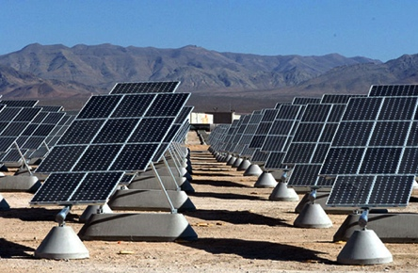

10

15

##### Biofuels

How does biofuel production work? In what ways can grassroots efforts towards energy independence connect with existing infrastructures?

**Dave** **Conz**, Assistant Research Professor, Center for Nanotechnology in Society, ASU

Moderator: Cynthia Selin



##### Transportation

How might transportation change over the coming decades? In what ways are social values and relationships shaped by our modes of transportation?

**Rider Foley**, Doctoral Student, Center for Nanotechnology in Society, School of Sustainability, ASU

**Aaron** **Golub**, Assistant Professor, School of Geographical Sciences and Urban Planning and School of Sustainability, ASU

**Wulf Grote**, Director of Planning and Development, Valley Metro

**Ben McCawley**, Traffic Signal Analyst, City of Chandler

Moderator: Mindy Kimball

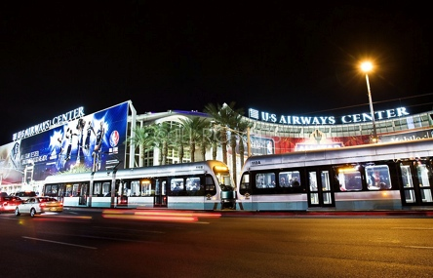

14

11

##### Graffiti

Silica particles at the nanoscale have the ability to repel both water-based and oil-based paints. Sprayed onto a surface of a building, the graffiti paint cannot stick to the surface.

City governments continuously clean public walls. Is this a good solution to the problem? Who wins, who loses?

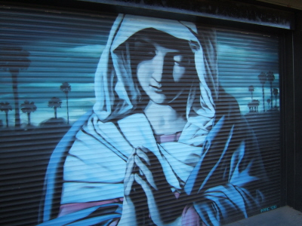

##### Pavement

Nanotechnology promises to improve pavements, both asphalt and concrete, in several ways.  Nanoclays can make pavement stiffer to withstand more force and not crack under pressure.  Nanoparticles can create stronger bonds to help pavement maintain shape, keeping roads flatter, leading to less work for vehicles, resulting in better fuel economy and less pollution. Nanosensors can be built into roadways for easier maintenance and better safety monitoring.

What is the fate of these nanoparticles and nanosensors when pavement is eventually ripped up, removed, or repaired? Will our waterways be impacted by nanoparticles? And will more efficient roadways enable more vehicle transportation and thus outweigh the benefits?

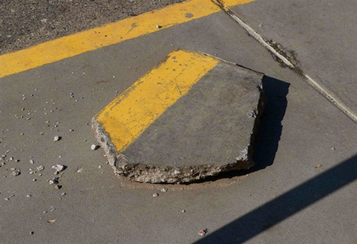

12

13