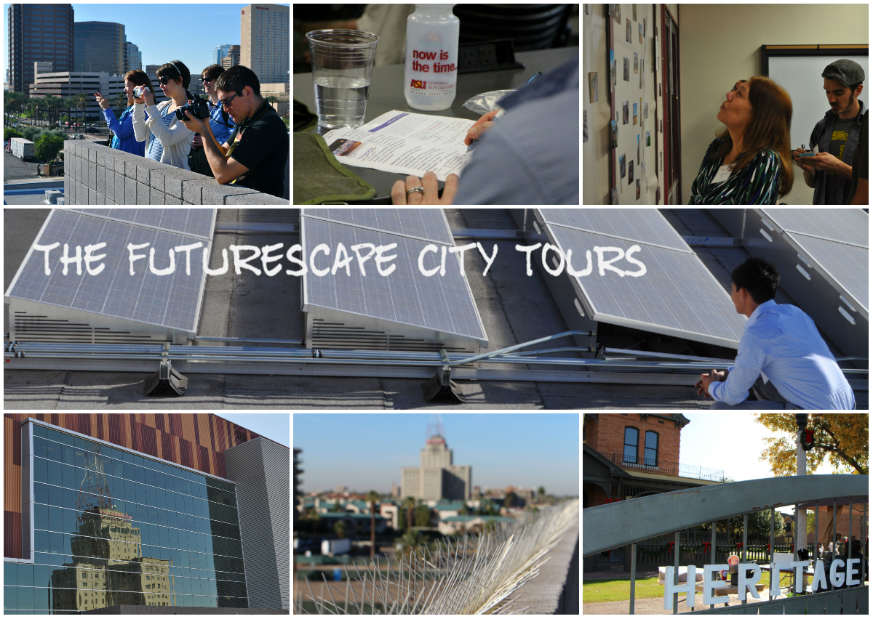

Materials to bring –

- IRB forms
- nametags
- parking validations
- Camera
- NanoDays posters.
- Power Point
- Nanoequity game
- Markers
- post-its
- easels
- paper
- pens

Aims of Session for Participants:

- Understand the purpose and logistics of the Futurescape City Tours
- Trust in process
- Build capacity for group discussions
- Develop, share and refresh ideas about the future of Phoenix
- Appreciate concepts like anticipatory governance and path dependency
- Articulate and challenge assumptions about technological change in relation to the urban environment, particularly in regards to our framing “values, systems, and social relationships”

Aims for Researchers:

- Appreciate and learn about the curiosities and concerns of the citizen group
- Derive sites for Session II Tour
- Facilitate with an eye towards equitable participation
- Note how objects matter for the dialogue
- Participants: who’s coming? Total will be about 15

First name Last name | P | email | Occupation
X alaway | P |  | "Odysee of the mind" program director
X ildirim | P |  | Media Arts & Sciences PhD student
X ornejo | P
Sylvia X | E |  | Electrical engineering
Dulce X | P |  | PhD student
Robert X | S |  | author of "Vanishing Phoenix"
Shannon X | P |  | nurse
Scott X | P |  | Librarian
Perry X | P |  | 9th grade history teacher
Roger X | E |  | engineer (Semiconductors)
Blakely X | P |  | Soundwalks
Art X | P
Jim X | S |  | wireless telecommunications
Wendoly X | S |  | community capacity building
Paul X | S |  | hobbies: photography, 3D printing
Julie X | P |  | She won't be in the first meeting

Location –
Arizona State University
Mercado (C135)
502 E. Monroe St., Building C
Phoenix, AZ 85004

Pre-work and thought starter questions:
- 3 examples of profound technological change that you’ve experienced in your lifetime. Consider how commuting to work, buying groceries, raising kids, visiting the doctor, etc. have changed over the years.
* 3 things you are concerned or excited about for the future of Phoenix.

Things to talk about on Monday:
Discussion prompts
Car pool
Note-taking guidelines: comprehensive plus audio to fill in gaps
Facilitation guidelines: elicit more than shape
Flyer for gallery show: not as a requirement, but as an appeal
Materials in order

Room set up:
Food table
‘Registration’ desk
Cool bags with camera, pen and notebook
Flyers on FCT

Day One – Nov 5th 4:30 pm – 8 pm
Time | Focus | Methodology | Notes
3:30 pm | Depart CSPO | Car pool | Haul materials
4:15 pm | Arrive @ Mercado
4:30 pm | Set-up | Mindy & Kelly: Welcome & Check-in participants  Carlo & Kathryn: Room set-up (color coded tables, chairs, refreshments, dinner table)  Jathan and Cynthia: PPT, posters | Sign IRB form  Water and Mindy’s cookies  AZ Iced tea
5:00 | Welcome | Cynthia:  What is CNS & anticipatory governance? (We do govern; problem with technology fast/ governance slow)  About Futurescape City Tours  Nano and the City  Why deliberate? (Technology in everyday life shapes us and we it; 21st c politics; people matter/ your voice matters; socially responsible technological change)  3 sessions: your concerns; your tour; your thoughts  Ground rules- anything else we should add? | Light touch to spark interest  Set ground rules- fair dialogue  Set tone- inquisitive and open
5:15 | Introduction to NanoEquity game | Kathryn (brief intro): Let’s play a game  Developed by CNS  OK if you know a little, a lot, or nothing about nano; we will provide you more information later, but to get your feet wet… | 1 minute introduction to how to play
5:30 | Game De-Brief | Jathan: How was the game play for you? What happened?  What struck, surprised you about the game?  Transition: we shift from nano in a global sense, to nano in your everyday lives, and as more to do with Phoenix | As a means to draw out winners/losers; technology is broad and part of a complex system;  Notes: Kelly (also use phone)
5:45 | 3 Looks at Technology | Mindy (asphalt)/ values  Jathan (cell phones)/ social interactions  Carlo (tomatoes)/ social systems  Inspired by the 10 Big Ideas, these 3-5 minute looks at ‘what is technology’ draw out the social, political, ethical and economic entanglements of technology. | Drives home some points from the Equity game;

Time | Focus | Methodology | Notes
6:00 pm | Break for dinner | Bathrooms are…  We will have discussions during dinner, so grab food and sit. We will discuss your views on technological change… | Table assignments/ 3 groups of 5
6:15 pm | Dinner Discussion:  Technological Change | Cynthia introduction  Mindy, Jathan and Carlo to facilitate at tables  Names & what motivates you to participate? Why are you here?  Driving questions:  Discussion facilitated with focus on stretching outward and into the future- creative, disruptive, contrary thinking encouraged.  Facilitators to bear in mind balance- is everyone speaking? Probe responses for deeper drivers and to question taken for granted understandings.  Cynthia close: Switch tables- 2nd color | Drawing from participants’ 3 examples of technological change, this ‘sharing’ discussion is to get folks talking and exchanging ideas about their relationship to and understanding of technology  Notes: Cynthia, Kathryn and Kelly  No report out
6:35 pm | Caption Practice | Thinking and Writing with and about images  3mins Explain Why? Begin thinking about visions of the city in context with our discussions about T change, desires, Explain what they’re to do (choose an image from the slide and write a caption to that images using some of the prompting questions0  2mins: Go, they write captions  5mins: In small groups, they share which image they chose and what they wrote and why. | Handout worksheets for caption writing  Use our images or change, whatever you prefer  Collect worksheets afterward
6:45 pm | Group Work:  3 concerns for the future of Phoenix | Kelly:  6:45pm - explain [to determine what to explore further]  6:50-7:05pm: round 1 & 2  7:05-7:25 minutes: open  7:25-7:35: final round  7:35-7:50: Generate list (What does this have to do with technology? What are your main concerns?) | What do you value most about Phoenix (that you would like to see preserved)? What troubles you (that you would like to see transformed)?  What are the most important sustainability challenges facing your city?  What role will technology play in addressing those challenges?
7:45 pm | Closing remarks | Cynthia: slides to speak from…
8:00 pm | End |  | Group de-brief?

Post Meeting:
Monday evening: Everyone jot down ½ page reflection on how it went: highs, lows, lessons learned; potential topics and sites
All workshop notes to Jathan & Cynthia for compiling (by Tuesday 11/6 @ 2pm)
To Do Afterward
- De-brief (open meeting): Tuesday 11/6 @ 2-3:30pm CSPO
- Meeting to ID sites in Phoenix (with Rider Foley). Wednesday 11/7 @ 9-11am, CSPO conference room

